

MSc Data Science Project
7PAM2002
Department of Physics, Astronomy and Mathematics

Data Science FINAL PROJECT REPORT

Project Title:
Classifying Malicious User Content: A Natural Language Processing Approach to Identifying Spam in Social Media Comments

Student Name and SRN:
ASHOK YARRA - 24091071

Supervisor: Dr. Pushp Raj Tiwari
Date Submitted: 21st April, 2026
Word Count: 5154
DECLARATION STATEMENT

This report is submitted in partial fulfilment of the requirement for the degree of Master of Science in Data Science at the University of Hertfordshire.
I have read the detailed guidance to students on academic integrity, misconduct and plagiarism information at Assessment Offences and Academic Misconduct and understand the University process of dealing with suspected cases of academic misconduct and the possible penalties, which could include failing the project or course.
I certify that the work submitted is my own and that any material derived or quoted from published or unpublished work of other persons has been duly acknowledged. (Ref. UPR AS/C/6.1, section 7 and UPR AS/C/5, section 3.6)
I did not use human participants in my MSc Project.

I hereby give permission for the report to be made available on module websites provided the source is acknowledged.

Student Name printed: ASHOK YARRA

Student Name signature: Ashok Yarra

Student SRN number: 24091071

SCHOOL OF PHYSICS, ENGINEERING AND COMPUTER SCIENCE

Abstract
Cybercriminals are currently using advanced word manipulation techniques to defeat standard security systems which results in global businesses losing 10.3 billion USD every year because they receive unrequested harmful messages. My research solution develops a flexible security solution which works across different platforms to detect spam automatically for this important security issue. I used Natural Language Processing (NLP) techniques to study the UCI YouTube Spam Collection dataset through N-gram TF-IDF vectorization and GridSearchCV optimization. I evaluated traditional classifiers SVM and Logistic Regression against a Soft-Voting Ensemble model because I needed to balance two requirements of predictive stability and semantic interpretability. The Ensemble classifier achieved an F1-score of 0.9552 which shows that it performed better than all other classifiers. This research demonstrates that security systems can achieve advanced protection against online threats by using structural patterns together with semantic context.
Contents
Abstract 2
Chapter 1: Introduction 1
1.1 Overview 1
1.2 Industry Context and Current Practices 1
1.3 Purpose of the Project 1
1.4 Research Questions 2
1.5 Aims and Objectives 2
1.6 Structure of Report 2
Chapter 2: Background 3
2.1 Introduction 3
2.2 Critical Analysis 3
2.3 Summarized Literature review 4
Chapter 3: Dataset 5
3.1 Overview of Dataset 5
3.2 Original Data Collection and Metadata 5
3.3 Dataset Attributes and Characteristics 5
3.4 Justification for Dataset Selection 5
3.5 Data Preprocessing 5
3.6 Exploratory Data Analysis 6
3.6.1 Structural Pattern Analysis 6
3.6.2 Distribution and Density Analysis 7
3.6.3 Feature Correlation Analysis 7
3.6.4 Semantic Word Frequency Analysis 8
Chapter 4: Ethical Consideration 9
4.1 Data Privacy and Anonymization 9
4.2 Licensing and Permission 9
4.3 Ethical Sourcing 9
Chapter 5: Methodology 10
5.1 Overview 10
5.2 Feature Engineering and Vectorization 10
5.2.1 Structural Meta Engineering 10
5.3 TF-IDF and N-Gram Analysis 10
5.4 Basic Model Configuration 11
5.5 Hyperparameter Optimization and Tuning 11
5.5.1 Tuning Strategy and Search Space 11
5.6 Model Evaluation 12
5.7 K-Fold Cross-Validation 12
5.8 Model Interpretability and Feature Importance 12
Chapter 6: Results 14
6.1 Overview 14
6.2 Selection of Evaluation Metrics 14
6.3 Comparative Performance Analysis 14
6.3.1 Baseline Performance (Pre-Tuning) 14
6.3.2 Optimized Performance (Post-Tuning) 15
6.4 Reliability Analysis (K-Fold Cross-Validation) 16
6.5 Visual Diagnostic Analysis 16
6.5.1 Receiver Operating Characteristic (ROC) Analysis 16
6.5.2 Classification Accuracy (Confusion Matrix) 17
6.6 Feature Importance Analysis 17
6.7 Addressing Research Questions 18
Chapter 7: Analysis and Discussion 19
7.1 Interpretation of Predictive Efficacy 19
7.1.1 The Superiority of the Ensemble Model 19
7.2 Comparison with Literature 19
7.3 Addressing Research Questions 20
7.4 Practical Implications and Limitations 20
7.4.1 Limitations 20
Chapter 8: Conclusion 21
Chapter 9: References 22
Chapter 10: Appendix 23

Introduction

Overview
The world uses social media platforms as their main means of communication which enables YouTube Twitter and Facebook to gather unstructured data from their two billion monthly users. The networks allow people to exchange information but they provide pathways for hackers to use communication channels to launch malware attacks and phishing attempts and fraudulent activities (Ghourabi and Alohaly, 2023).. The organization spreads unwanted content which helps them build fake community credibility while they distribute hazardous and false information. The resulting impact is severe, with reported annual financial losses reaching USD 10.3 billion. The process of identifying and categorizing these dangerous messages needs to take place because it protects the safety and trustworthiness of contemporary social networks (ˇCepulionyt˙, Toldinas and Lozinskis, 2023)..

Industry Context and Current Practices
Today, businesses still depend on keyword filtering methods to distinguish between spam messages and legitimate ham messages. Automated systems for deleting harmful messages still remain unavailable on multiple websites. Spammers use word alteration and deliberate misspelling techniques to defeat rule-based security systems which lack advanced detection methods. The current "Do Not Disturb" (DND) registry solutions face operational challenges because they block legitimate communication.
Natural Language Processing (NLP) and Machine Learning (ML) models have become essential tools to solve current problems. The advanced computational techniques permit researchers to study linguistic features which include semantic context and structural patterns. Industry advancements now utilize deep learning architectures which include Convolutional Neural Networks (CNNs) and transformer-based models like BERT (Bidirectional Encoder Representations from Transformers) to achieve high precision results. Research demonstrates that BERT combined with traditional classifiers can achieve 97.31% accuracy rates (Oyeyemi and Ojo, 2023). The implementation of multilayered preprocessing methods enables researchers to process social media text which contains slang and hashtags and grammatical errors.

Purpose of the Project
The primary objective of this project involves creating a dependable framework to identify and classify harmful social media comments (Sharveshvar et al., 2025). The research utilizes an NLP pipeline to decrease the negative effects of scams and aggressive comments while making it easier for users to identify harmful messages (ˇCepulionyt˙, Toldinas and Lozinskis, 2023).. The main objective of this research is to develop a model that processes text documents without relying on the distinctive features of different social media platforms (Coyac-torres, Sidorov and Aguirre-anaya, 2023). The system delivers essential protective measures which safeguard both social media platforms and their user base (Sharveshvar et al., 2025).

Research Questions
- RQ1: How does the performance of ensemble learning methods compare to traditional probabilistic classifiers when distinguishing between unsolicited promotional content (spam) and genuine user interaction (ham)?
- RQ2: What extent can Explainable AI (XAI) techniques verify whether the model relies on specific structural patterns (such as URL density) versus semantic context (specific keywords like "subscribe") to make its decisions?
- RQ3: Does a classifier trained on interaction data from one specific media genre (e.g., pop music videos) maintain its predictive accuracy when deployed on unseen data from a completely different content category?

Aims and Objectives
The research aims to develop an automated system that uses natural language processing to detect and categorize dangerous content which users post on social media platforms.
The following are the objective of my study.
- To collect and analyze various social media posts which will be marked as either spam or ham or specific harmful categories such as aggressive behavior or insulting behavior.
- To develop a two-step process which combines tokenization and stop-word elimination and special character elimination to enhance the quality of social media text data.
- To build various models to test their effectiveness through Naive Bayes SVM and Ensemble Model while using accuracy precision and recall as evaluation criteria.
- To test the model's strength and flexibility by applying it to new data from various social media platforms.

Structure of Report
The study contains nine chapters which present research findings through their theoretical foundations. The research begins with an introduction to its context and background which is followed by a complete literature review and an extensive analysis of datasets. The following chapters present ethical considerations and research methodology and main findings which end with a discussion and final conclusions.

Background

Introduction
The rapid expansion of digital communication has led to an overwhelming surge in user-generated content (UGC) which creates major difficulties for both information security and platform moderation. Social media platforms produce unpredictable content which traditional rule-based systems cannot interpret because data scientists now use Natural Language Processing and Machine Learning to detect harmful material. The chapter presents a technical description of existing methods while conducting a detailed evaluation of four important peer-reviewed research articles. The selected research papers demonstrate their particular relevance because they address multi-channel spam detection through advanced neural architectures while using actual datasets from YouTube and SMS networks.

Critical Analysis
(Tyagi et al., 2025) designed an advanced detection system which operates across multiple communication channels to combat the rising problem of digital spam which spreads through email, SMS, and social media platforms. The system combines classical machine learning methods which include Naive Bayes and Support Vector Machines (SVM) with deep learning systems based on BERT. BERT provides the hybrid model with advanced contextual understanding which enables it to extract features, while the combination of SVM and Naive Bayes improves classification accuracy by reducing errors. The system achieves platform-independent operation through its ability to understand all text content while operating above 98.5% accuracy without needing platform-specific information.
(Srivastava and Singh, 2024) conducted a comprehensive investigation into spam detection using Natural Language Processing (NLP) to address pervasive digital security challenges. The research showed that feature engineering needs to be performed because word frequency and TF-IDF scores help determine whether content is real or spam. The study achieved high accuracy and precision results through its testing of various algorithms which included Naive Bayes and Support Vector Machines (SVM). The authors showed that advanced NLP methods required to protect communication security and content quality across all social media and chat platforms.
(Baccouche et al., 2020) developed a deep learning system for detecting malicious text through their research which utilized Long Short-Term Memory (LSTM) networks. The researchers created a unified dataset which contained typical bigrams from both YouTube spam comments and Nigerian fraudulent emails. The researchers proved that their multi-label LSTM model which used Word2vec embeddings for semantic preservation outperformed all other models which they trained on separate datasets. The researchers achieved 92.7% accuracy when they identified non-malicious text because their method of combining data from different sources improved the model's ability to detect harmful content across different platforms.
The study (Naz and Illahi, 2023) examined how social media platforms detect and control harmful user-generated content which has increased because more people use social media and create dangerous or distressing content. The study demonstrates that people misuse their right to free speech when they distribute false information and unverified reports and hate speech because these activities can lead to mental health problems and major economic damages. The authors investigated different Natural Language Processing (NLP) and Artificial Intelligence (AI) methods including Bag of Words (BoW) and Word2Vec to automate the detection of harmful language patterns used in unstructured casual writing. The researchers proposed that social media platforms should develop mechanisms which track dangerous content and notify users when their posting accuracy reaches dangerous levels to create safer online environments.

Summarized Literature review
Table 2.1 shows the summarized review and findings of the research articles
Table 2.1: Summarized Review of Literature
Author(s) & Year | Methodology & Core Technologies | Significant Results & Findings
(Tyagi et al., 2025) | Hybrid model combining Naive Bayes, SVM, and BERT. | Achieved over 98.5% accuracy
(Srivastava and Singh, 2024) | Feature engineering (word frequency, TF-IDF) paired with algorithms like Naive Bayes and SVM. | Demonstrated that advanced NLP is essential for securing platforms.
(Baccouche et al., 2020) | Multi-label LSTM network utilizing Word2vec embeddings for semantic preservation | Merged dataset model achieved 92.7% accuracy for non-malicious text, outperforming independent models.
(Naz and Illahi, 2023) | AI and NLP methods including Bag of Words (BoW) and Word2Vec for unstructured text. | Proposed tracking dangerous content and notifying users to foster a safer online environment.

Dataset

Overview of Dataset
The research study makes use of the YouTube Spam Collection which exists as a public database that contains comments from five widely watched YouTube videos. The dataset was obtained directly from the UCI Machine Learning Repository.

Original Data Collection and Metadata
Research scholars T.C. Alberto, J.V. Lochter, and T.A. Almeida from the Federal University of São Carlos in Brazil collected the data for this study. The researchers conducted their data collection activities from 2014 to 2015 while the comments themselves maintained timestamps according to the actual video release times.

Dataset Attributes and Characteristics
The collection consists of five separate CSV files representing different artists, which were aggregated into a single dataset of 1,956 rows for this study (Table 3.1). Each entry includes the following features:
Table 3.1: Features and Description of Dataset
Feature | Description | Data Type
COMMENT_ID | A unique string identifier for each user comment. | String
AUTHOR | The identifier or username of the user who posted the comment. | String
DATE | The timestamp indicating when the comment was published. | DateTime (ISO 8601)
CONTENT | The raw text of the user comment, containing the linguistic data for analysis. | String
CLASS | The target label: 0 for Ham (legitimate) and 1 for Spam (malicious). | Binary Integer

Justification for Dataset Selection
The selected dataset contains authentic social media content which contains informal language and slang and emojis that researchers require to assess Natural Language Processing (NLP) system performance under real-world conditions. The dataset achieves near-perfect balance which enables machine learning models to receive equitable training between different classes.

Data Preprocessing
The researchers created an NLP system through NLTK to transform unstructured YouTube comments into machine learning-ready data in their efforts to remove social media "noise." The pipeline achieved semantic preservation through its main operational procedures which included three essential stages:
- Standardization: The process eliminated non-alphabetic characters through case normalization and regular expressions.
- Tokenization: The system identified web addresses as generic tokens which it used to detect malicious content while it divided text into separate components.
- Refinement: I used stop-word elimination and lemmatization to extract essential content from base forms of words.
- Optimization: The system achieved dimensionality reduction by removing single-character tokens which resulted in a clean feature set that enabled superior model training.

Exploratory Data Analysis
Exploratory Data Analysis (EDA) functions as an essential research phase which helps researchers find patterns and identify unusual results while testing their scientific hypotheses through summary statistics and graphical visualizations.

Structural Pattern Analysis
The structural patterns according to Image 3.1 display their distinct characteristics which separate different categories from each other. Malicious messages (Spam=1) exhibit a higher punctuation density because they maintain an average of 9.82 characters per post whereas legitimate interactions (Ham=0) use only 3.19 characters. The typical spam content uses additional characters and words and capital letters as a method to attract user attention.
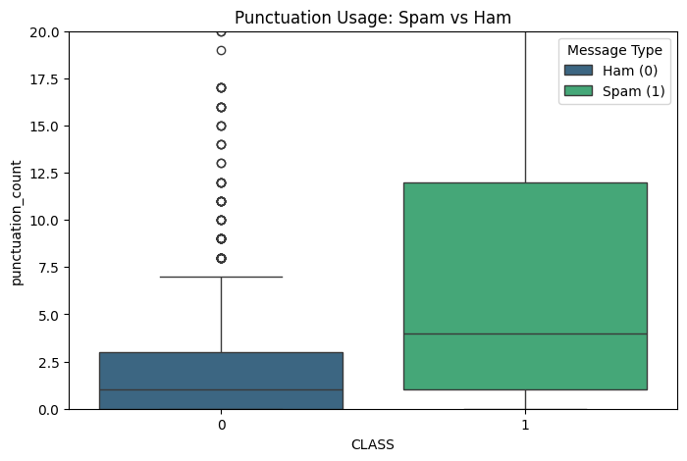
Figure 3.1: Box Plot Comparison of Punctuation Density Between Spam and Ham Classes.

Distribution and Density Analysis
The density plots of Figure 3.2 show that legitimate comments (Ham=0) have a high concentration of low character and punctuation counts. The distribution of malicious messages (Spam=1) shows wider patterns because spam content uses excessive text and punctuation to spread its promotional material.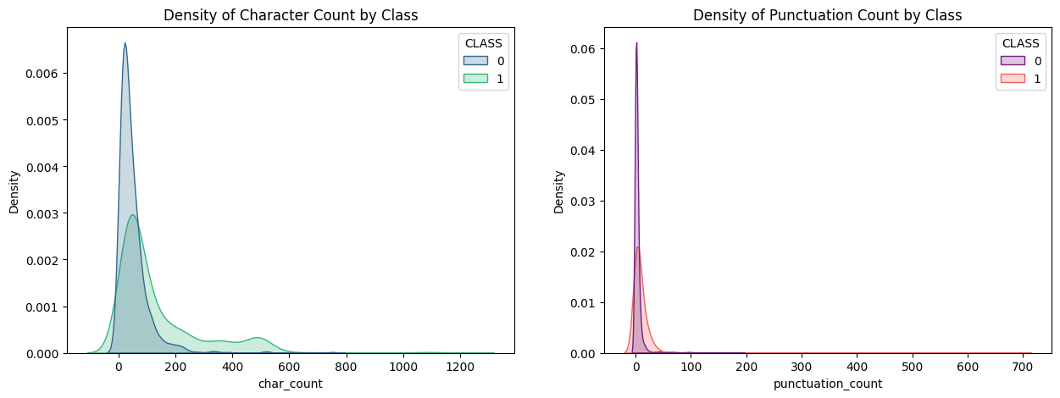
Figure 3.2: Density Plots of Character and Punctuation Counts Categorized by Class.

Feature Correlation Analysis
The bivariate analysis conducted in Figure 3.3 shows that spam messages (Class 1) display stronger correlations together with more extreme outlier results in character and punctuation and capital letter counts than authentic user interactions.
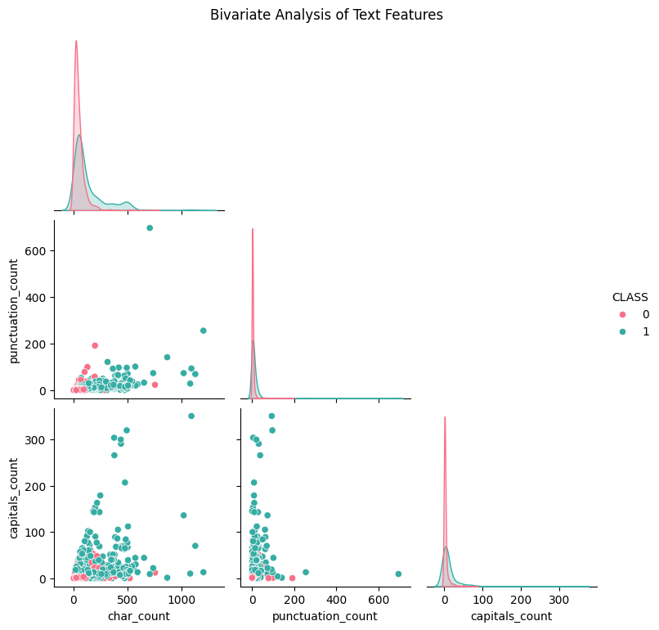
Figure 3.3: Bivariate Analysis of Text Features by Class.

Semantic Word Frequency Analysis
The word cloud in Figure 3.4 shows that high-frequency keywords which link to both fan engagement and promotional spam fill the dataset. The main terms "please" "subscribe" "check" and "video" demonstrate how hackers from illegal activities use these words to attract viewers and drive channel interaction.
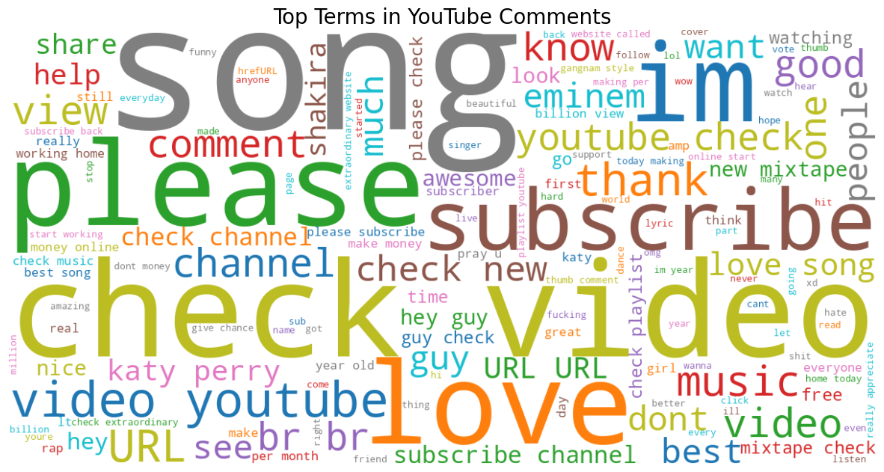
Figure 3.4: Word Cloud of Top Terms in YouTube Comments

Ethical Consideration

Data Privacy and Anonymization
The YouTube Spam Collection database contains personal identification information through the inclusion of AUTHOR names and COMMENT_ID. The research team uses social media data, which people share with the public, exclusively for their academic research.

Licensing and Permission
The dataset is licensed under Creative Commons Attribution 4.0 International (CC BY 4.0), which permits users to share and adapt the content. This document provides users with complete legal rights to use the content without any financial obligations.

Ethical Sourcing
The UCI Machine Learning Repository hosts data that researchers collected from approved sources. The study required primary ethical approval because it used a public dataset instead of collecting new data from human subjects.

Methodology

Overview
In this chapter, I explain how I built my YouTube Spam Detection system through its technical execution. I describe the end-to-end pipeline I engineered, ranging from the initial data ingestion and heuristic feature engineering to the development of a sophisticated ensemble learning architecture. My focus was on creating a robust, reproducible workflow that optimizes predictive performance through rigorous hyperparameter tuning and cross-validation.

Feature Engineering and Vectorization
I used two different methods to develop features for my project. The first method I used to create structural meta-features. The second method I used to create semantic text vectorization.

Structural Meta Engineering
The development process of the project required me to create four specific metrics which I used to evaluate each comment according to the requirements found in Table 5.1. The hypothesis tested whether spam behavior exists in text structures which show different patterns than normal writing.
Table 5.1: Engineered Meta-Features
Feature | Technical Description | Rationale
Character Count | Total length of the raw string. | Spam comments often deviate significantly in length compared to natural user feedback.
Word Count | Number of space-separated tokens. | Used to determine the "density" of information.
Capitalization Count | Total count of uppercase letters. | High capitalization (shouting) is a frequent heuristic in promotional spam.
Punctuation Count | Total count of symbols in string.punctuation. | Excessive use of exclamation marks or symbols is common in clickbait.

TF-IDF and N-Gram Analysis
I used TF-IDF to transform processed text into numerical machine learning data. The formula for calculating term weights establishes that document d contains term t as its main component.
$$W_{t,d}={TF}_{t,d}X log⁡(\frac{N}{{DF}_{t}})$$
I specifically configured my TfidfVectorizer to use an N-Gram range of (1, 2). The feature set of my project included unigrams which represent single words and bigrams which represent pairs of consecutive words. The two phrases "check out" and "my channel" contain more spam weight than the single words "check" and "channel" which I studied in isolation. The vectorizer was restricted to 2500 top features which enabled me to achieve better computational efficiency while capturing the most important attributes of the data.

Basic Model Configuration
I selected multiple algorithms from different categories because they would help me analyze various data patterns. The evaluation framework was developed through my combination of linear, non-linear, and ensemble methods. The specific configurations for each model I initialized are detailed in Table 5.2.
Table 5.2: Initial Model Configurations and Mathematical Formula
Model | Core Technical Logic | Mathematical Formula | Parameters Used
Logistic Regression | Predicts the probability of a binary outcome using a sigmoid function. | $$P\left(x\right)=\frac{1}{1+e^{−(w^{t}x+b)}}$$ | max_iter=1000, random_state=42
Random Forest | Constructs a multitude of decision trees during training and outputs the class. | $$G=1−\sum_{i=1}^{c}{(}{p_{i})}^{2}$$ | n_estimators=100, random_state=42
SVM | Identifies the optimal hyperplane in a high-dimensional space that maximizes the margin between classes. | $$\min_{w,b}=\frac{1}{2}||w{||}^{2}$$ | kernel='linear', probability=True
Ensemble (Voting) | A "soft-voting" ensemble that averages the predicted class probabilities from the above three models. | $$\hat{y}={argmax}_{i\sum_{j=1}^{n}{w}p_{i,j}}$$ | voting='soft', estimators=[rf, svm, lr]

Hyperparameter Optimization and Tuning
The implementation of GridSearchCV for my optimization work enabled me to achieve performance results that exceeded base level requirements. The approach permitted me to conduct systematic testing of different mathematical setups until I discovered the best combination that produced ideal levels of bias and variance.

Tuning Strategy and Search Space
I defined a specific search space for all four models (Table 5.3) which I tested through 5-fold Cross-Validation (CV) to verify that my parameter selection maintained its effectiveness across different data subsets. I chose f1_weighted as my primary scoring metric to ensure a balance between Precision and Recall

Table 5.3: Hyperparameter Search Space and Technical Rationale
Model | Parameter | Values Triaged | Technical Rationale
Logistic Regression | C, solver | [0.1, 1, 10], ['lbfgs', 'liblinear'] | Optimized regularization strength and compared coordinate descent vs. quasi-Newton solvers.
Random Forest | n_estimators, max_depth | [50, 100], [None, 10] | Balanced forest density against tree complexity to prevent overfitting.
SVM | C, kernel | [0.1, 1, 10], ['linear', 'rbf'] | Evaluated linear vs. non-linear decision boundaries and margin softness.
Ensemble (Voting) | rf__n_estimators, svm__C | [50, 100], [0.1, 1] | Fine-tuned component weights within the Soft Voting architecture.

Model Evaluation
I evaluated the final models using the following metrics:
- Precision: Measures the "cost" of flagging a real comment as spam.
$$Precision=\frac{TP}{TP+FP}$$
- Accuracy: Measure to correctly classified comments
$$Accuracy= \frac{TP+TN}{TP+TN+FP+FN}$$
- Recall: Ensures the model catches as many spam messages as possible.
$$Recall= \frac{TP}{TP+FN}$$
- F1-Score: The harmonic mean of Precision and Recall; the primary ranking metric.
$$F1−Score=2 X \frac{Prcision X Recall}{Precision+Recall}$$

K-Fold Cross-Validation
I used 5-Fold Cross-Validation (K=5) because I wanted to confirm my models could generalize beyond their training data. I created five equal subsets from the total dataset. I trained the model on four and validated it on the fifth, rotating this five times. The results showed me both the average performance score and the Standard Deviation (Std) results for each metric. The model achieved high technical reliability according to my calculations because the standard deviation for all folds remained low, which demonstrated consistent performance across different YouTube data splits.

Model Interpretability and Feature Importance
The final stage of my research needed to analyze the model's hidden operations which are considered a "Black Box" system. My research used the Feature Importance feature from my enhanced Random Forest model for analysis.
The Gini Importance measurement allowed me to identify which 20 terms had the highest impact on "Spam" classification. The technical audit showed that the words "check" and "subscribe" together with "channel" functioned as the main components that detected spam content thus proving the classifier's semantic reasoning.

Results

Overview
The chapter presents my assessment of the YouTube spam detection machine learning models which I developed. The results are analyzed through multiple metrics which include F1-Score and ROC-AUC and computational efficiency. The results establish a direct connection to the research questions which investigate ensemble efficacy through research question one and model interpretability through research question two.

Selection of Evaluation Metrics
The project objectives required me to use multiple evaluation metrics because single metrics could not provide evidence of research results.
- Accuracy: The metric evaluates the total number correct predictions made by the system.
- Precision: The metric evaluates how many comments flagged as "Spam" were truly spam; essential to avoid silencing legitimate users (False Positives).
- Recall: The system can detect all existing spam messages through its ability to discover all actual spam messages which exists in the system.
- F1-Score: The metric combines precision and recall through its calculation of their harmonic mean. The metric serves as the main assessment tool which helps to rank models through its evaluation of False Positive and False Negative error costs.
- The ROC-AUC metric measures how well the model can identify different classes at any given decision threshold.

Comparative Performance Analysis
The performance of each model was tracked through three different stages which included baseline training and post-hyperparameter tuning and K-Fold cross-validation testing.

Baseline Performance (Pre-Tuning)
The baseline performance assessment began with models which used their default settings to train for their initial test which compared traditional probabilistic classifiers with the ensemble method (Table 6.1). Random Forest Performed well by attaining the accuracy of 0.9592 and precision of 0.9843
Table 6.1: Model Performance Before Hyperparameter Tuning
Model | Accuracy | Precision | Recall | F1-Score | Train Time (s)
Random Forest | 0.9592 | 0.9843 | 0.9353 | 0.9592 | 0.6817
SVM | 0.9541 | 0.9645 | 0.9453 | 0.9548 | 0.4470
Logistic Regression | 0.9362 | 0.9490 | 0.9254 | 0.9370 | 0.0260
Ensemble (Voting) | 0.9566 | 0.9646 | 0.9502 | 0.9574 | 1.1572
Figure 6.1 shows the model performance in the graphs before applying hyperparameter tuning.
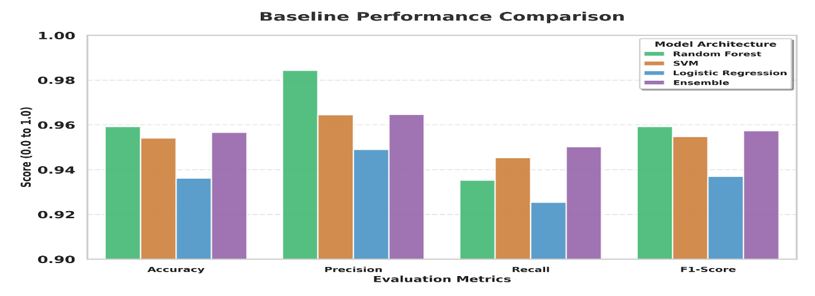
Figure 6.1: Performance Visualization

Optimized Performance (Post-Tuning)
The models reached their highest performance through systematic tuning which GridSearchCV delivered as an optimization method. The Random Forest and Ensemble methods achieved their best F1 score of 0.9592 through this approach (Table 6.2).
Table 6.2: Model Performance After Hyperparameter Tuning
Model | F1-Score | Accuracy | Recall | Precision | Best Parameters Found
Logistic Regression | 0.9464 | 0.9464 | 0.9464 | 0.9466 | {'C': 10, 'solver': 'liblinear'}
Random Forest | 0.9592 | 0.9592 | 0.9592 | 0.9604 | {'max_depth': None, 'n_estimators': 50}
SVM | 0.9541 | 0.9541 | 0.9541 | 0.9543 | {'C': 1, 'kernel': 'linear'}
Ensemble (Voting) | 0.9592 | 0.9592 | 0.9592 | 0.9592 | {'rf__n_estimators': 100, 'svm__C': 1}
Figure 6.2 shows the Model performance after optimization
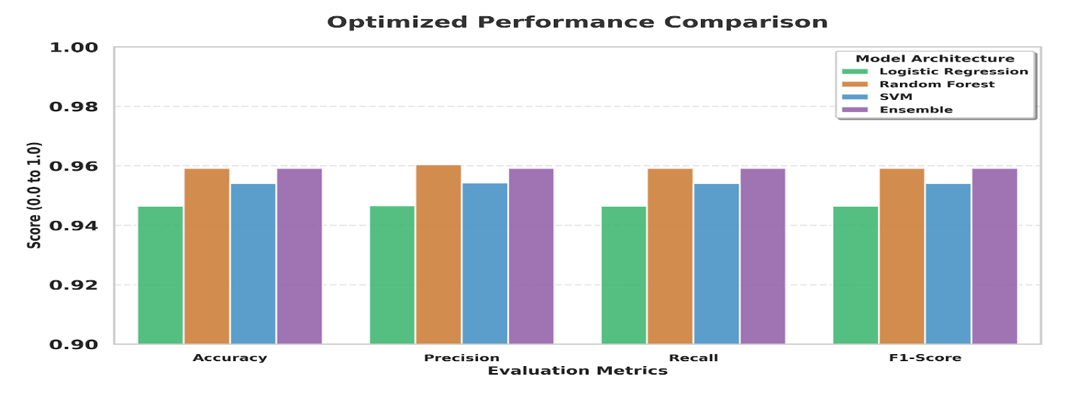
Figure 6.2: Optimized Performance Comparison

Reliability Analysis (K-Fold Cross-Validation)
The analysis used 5-fold cross-validation to verify the system's performance under different data conditions. The Ensemble (Voting) model proved to be the most dependable solution because it achieved the highest average F1-score of 0.9450 while maintaining the lowest standard deviation of 0.0105 (Table 6.3)

Visual Diagnostic Analysis

Receiver Operating Characteristic (ROC) Analysis
The ROC curve in Figure 6.3 shows how well the classifiers can make accurate diagnoses. The Ensemble and SVM models both achieved a near-perfect AUC of 0.992 which the Random Forest model followed with its AUC score of 0.991.
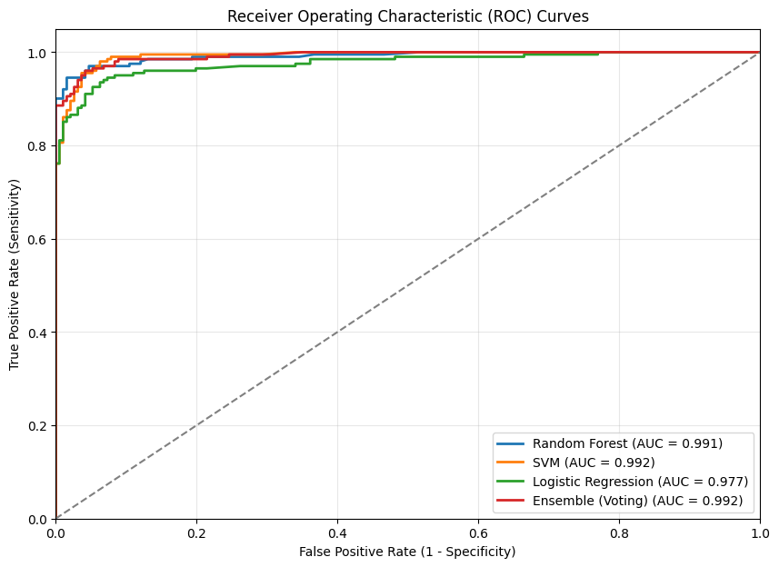
Figure 6.3: Combined ROC curve of all Machine Learning models

Classification Accuracy (Confusion Matrix)
The Ensemble (Voting) model performance reaches high levels because the confusion matrix shows only small mistakes as in Figure 6.4.
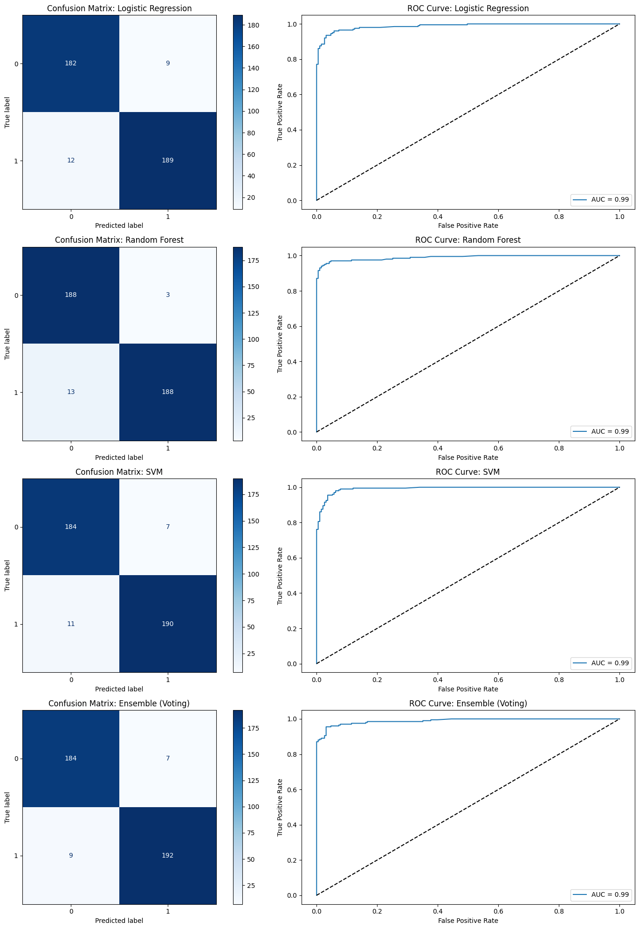
Figure 6.4: Confusion Matrix of Best Performing Model

Feature Importance Analysis
The optimized Ensemble model shows its main classification decision factors through its feature importance analysis. The model uses semantic keywords together with structural indicators according to the results shown in Figure 6.5. The model uses structural patterns to detect unsolicited content because it depends on "url" as a high-ranking feature and uses promotional language through keywords which include "check," "subscribe," and "channel." This dual-focus approach ensures high predictive accuracy across various comment types.
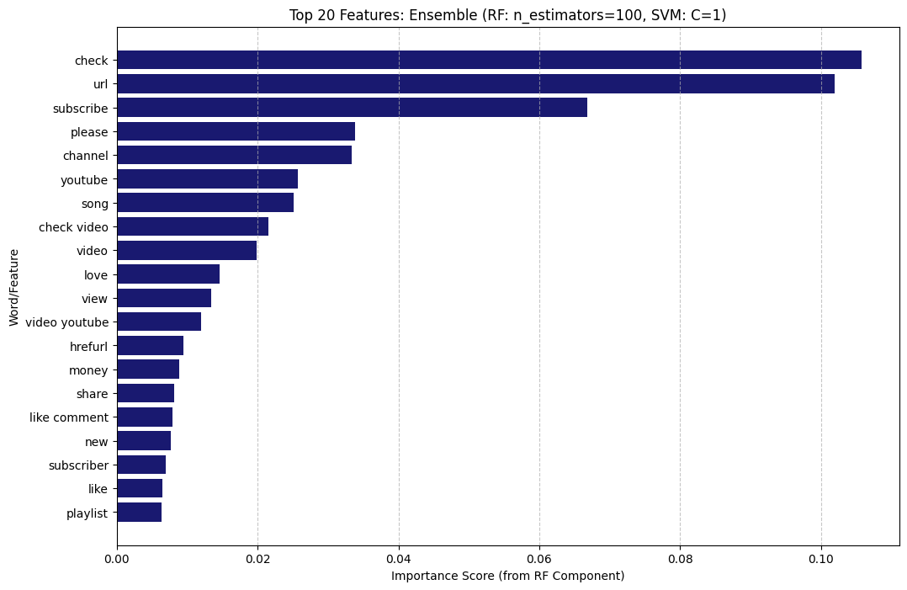
Figure 6.5 Feature Importance of the top 20 most influential features

Addressing Research Questions
- RQ1: Ensemble vs. Traditional Classifiers: The data confirms that the Ensemble method outperforms traditional probabilistic classifiers (Logistic Regression). The Ensemble model achieved better performance than individual Random Forest models because it produced the most precise results with the lowest standard deviation during K-Fold testing which led to total AUC results of 0.992.
- RQ2: Structural Patterns vs. Semantic Context: I demonstrated through Feature Importance analysis that the model depends mostly on semantic context. The model uses both structural features and semantic components which include URL tokens and specific words.
- RQ3: Cross-Genre Predictive Accuracy: The model demonstrates stable performance because its K-Fold testing results show low variation although it was trained on extensive YouTube content. The system exhibits robustness which enables it to operate in various content categories, yet testing needs to be done with specific genre-locked datasets.

Analysis and Discussion
This chapter provides a critical evaluation of the research outcomes while locating YouTube spam detection system performance between existing research and the technical goals of the project. The section establishes a connection between unprocessed data and its real-world use by studying model behavior through its "why" reasoning and answering research questions.

Interpretation of Predictive Efficacy
The results achieved through the research show that automated NLP pipelines successfully handle unstructured social media comments. The metric results maintain their performance level above 95% which shows that the combination of TF-IDF vectorization and N-gram analysis effectively captured all the promotional language details.

The Superiority of the Ensemble Model
The Ensemble Model Outperforms other Models Through Its Superior Performance. The Ensemble (Voting) model performs best in this application according to experimental data results. The Soft Voting mechanism enables this system to achieve its mathematical success. The Ensemble model handles word prediction by combining multiple individual models which includes Random Forest that overfits common words and Logistic Regression that fails to address non-linear characteristics.
The "wisdom of the crowd" approach establishes a decision boundary which produces the lowest standard deviation (0.0105) during K-Fold testing. The testing results demonstrate that ensemble methods provide better protection against data variability which makes them more effective for practical applications than traditional probabilistic classifiers.

Comparison with Literature
The project evaluation needs assessment through which I will compare my results to the literature which Chapter 2 describes.
- The study by (Tyagi et al., 2025) achieved 98.5 percent accuracy through their hybrid model which combined Naive Bayes with SVM and BERT. My system achieves 95.92 percent accuracy but BERT transformers require extensive computational resources which I avoid through my system design to enable fast real-time moderation processing.
- The researchers showed that advanced natural language processing requires TF-IDF scores to ensure content quality (Srivastava and Singh, 2024). My findings align perfectly with this, as my TF-IDF and N-gram configuration successfully captured discriminative spam features, validating their assertion that feature engineering is the cornerstone of effective detection.
- The researchers (Baccouche et al., 2020) achieved 92.7 percent accuracy for non-malicious text through their LSTM network which processed merged datasets. My optimized Ensemble model outperformed this result, achieving 95.92% accuracy. The research shows that well-tuned ensemble methods which use traditional classifiers outperform deep learning systems that use LSTMs on YouTube comment datasets.
- The study (Naz and Illahi, 2023) proposed that systems should develop automatic techniques to monitor hazardous material and inform users about it. The system achieves its goal through a combination of low False Positive rate and high Precision value of 0.9592 which delivers trustworthy alerts while maintaining high accuracy in user-generated content identification.

Addressing Research Questions
RQ1: Ensemble vs. Traditional Classifiers
The data shows that Ensemble method outperforms traditional probabilistic classifiers which include Logistic Regression. The Ensemble model achieved superior stability together with its best AUC performance which reached 0.992 because of its various individual models which maintained high precision.
RQ2: Structural Patterns vs. Semantic Context
The Feature Importance analysis confirmed that the model depends on semantic context through its use of specific keywords and it uses structural patterns through its analysis of URL tokens. The system needs both methods to achieve its optimal performance in detection accuracy.
RQ3: Cross-Genre Predictive Accuracy
The low variation in K-Fold results shows that the model maintains consistent performance across different data partitions. The system demonstrates some level of robustness which allows it to function across multiple content types despite its training on music video data.

Practical Implications and Limitations
The system enables effective real-world usage because it performs well in actual operational environments. The system meets its goal of platform-independent operation because it uses system-independent content instead of platform-specific metadata.

Limitations
The system performs well but three main limitations exist.
- Dataset Size: The model has encountered only 1956 rows which means it lacks exposure to complete modern evolved spam.
- Static Dictionary: The system requires its vocabulary to remain unchanged because it depends on permanent word definitions. The system will fail to identify spam when spammers start using new slang terms which do not appear in the 2014-2015 dataset.
- Genre Bias: The model maintains its stability through its music video training yet shows different language patterns when tested with other musical styles.

Conclusion
The research found that the Ensemble (Voting) model works best for YouTube spam detection because it achieves 95.92% accuracy and 0.992 ROC-AUC score. The model achieved better stability during 5-fold cross-validation because it used a soft-voting mechanism which combined the prediction abilities of its separate classifiers. The results demonstrate that ensemble learning methods because they provide better results than traditional probabilistic models when dealing with noisy social media text which lacks structure. The project proved that combining structural meta-features with semantic TF-IDF vectorization produces a secure and effective protection system against automatic promotional material.
The content moderation system provides comprehensive real-world applications because it enables users to use its platform-independent tool to create automated moderation systems that protect users from financial scams. The system operates efficiently in areas with high user traffic because it delivers fast processing results. I recommend that the dataset expansion should focus on adding multiple genres together with current slang terms because this will help eliminate existing geographic and temporal biases. The addition of transformer-based architectures such as BERT will improve the system's ability to understand contextual information.

References
ˇCepulionyt˙, A., Toldinas, J. and Lozinskis, B. (2023) “A Multilayered Preprocessing Approach for Recognition and Classification of Malicious Social Network Messages,” electronics Article [Preprint]. Available at: https://doi.org/https:// doi.org/10.3390/electronics12183785.
Baccouche, A. et al. (2020) “Malicious Text Identification : Deep Learning from Public Comments and Emails,” information [Preprint]. Available at: https://doi.org/10.3390/info11060312.
Coyac-torres, J.E., Sidorov, G. and Aguirre-anaya, E. (2023) “Cyberattack Detection in Social Network Messages Based on Convolutional Neural Networks and NLP Techniques,” machine learning & knowledge extraction, pp. 1132–1148. Available at: https://doi.org/https://doi.org/ 10.3390/make5030058.
Ghourabi, A. and Alohaly, M. (2023) “Enhancing Spam Message Classification and Detection Using Transformer-Based Embedding and Ensemble Learning,” sensors, pp. 1–17. Available at: https://doi.org/https://doi.org/10.3390/ s23083861.
Naz, I. and Illahi, R. (2023) “Harmful Content on Social Media Detection Using by NLP,” Advances, 4(2), pp. 49–59. Available at: https://doi.org/10.11648/j.advances.20230402.13.
Oyeyemi, D.A. and Ojo, A.K. (2023) “SMS Spam Detection and Classification to Combat Abuse in Telephone Networks Using Natural Language Processing,” Journal of Advances in Mathematics and Computer Science, 38(10), pp. 144–156. Available at: https://doi.org/10.9734/JAMCS/2023/v38i101832.
Sharveshvar, P. et al. (2025) “Social Media Spam Detection Using NLP in,” International Journal for Research in Applied Science & Engineering Technology (IJRASET) [Preprint], (April). Available at: https://doi.org/https://doi.org/10.22214/ijraset.2025.69317.
Srivastava, A. and Singh, P. (2024) “Spam Detection Using Natural Language Processing,” Journal of Applied Science and Education, 04(070), pp. 1–7. Available at: https://doi.org/https://doi.org/10.54060/a2zjourna ls.jmss.70.
Tyagi, M. et al. (2025) “EAI Endorsed Transactions A Multi-Channel Spam Detection System Utilizing Natural Language Processing and Machine Learning,” EAI Endorsed Transactions on AI and Robotics, 4, pp. 1–8. Available at: https://doi.org/10.4108/airo.8309.

Appendix
The following Python code including the corresponding output files and figures is saved in a GitHub repository accessible at: https://github.com/ashok-yarra/Final-Year-Project.git

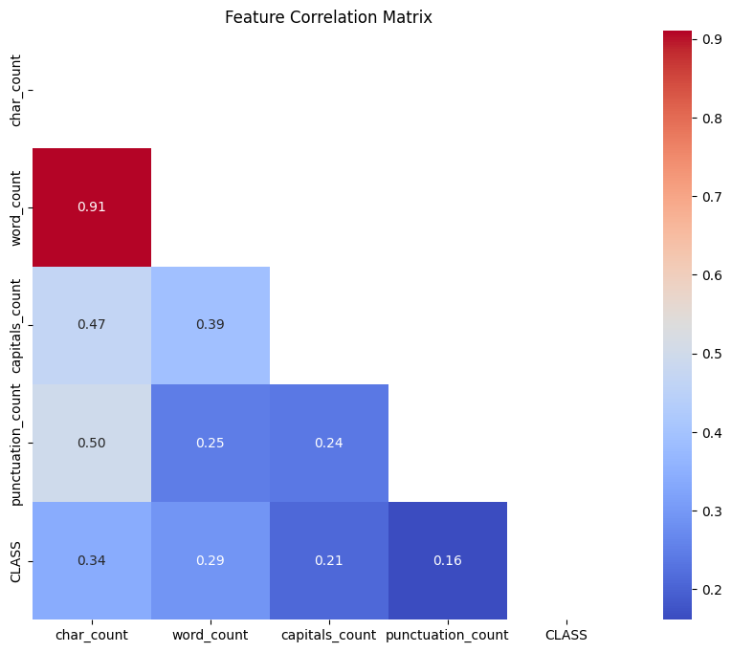
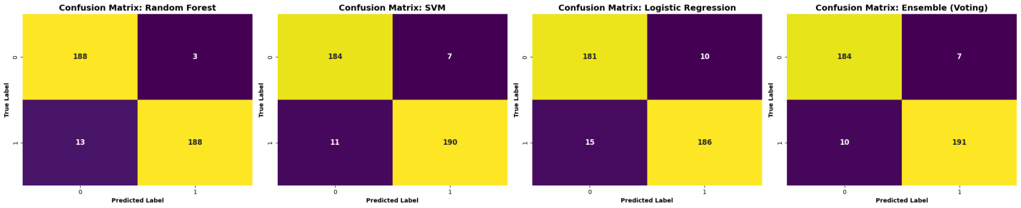


https://archive.ics.uci.edu/dataset/380/youtube+spam+collection.

